**Date: June 17, 2014**

**Subject: JIRA PoC - Executive Summary**

**Business Owner(s) Mike Kerr (Systems Engineering Group, Dept 460001), Dan Morcom/Ward Nelson**

**IS&T Represenatives: David Hinz (IS&T HPC and Cloud Solutions Dir), Paul Buenrosto**

* **Purpose/Desired Outcome (Information/Decision):**

With an outside vendor, create an enterprise deployment of JIRA to determine if JIRA can meet the needs of HGST software development teams as a replacement for FogBugz and other defect tracking tools.

* Evaluate JIRA against documented requirements for defect tracking during code development.
* Conversion of current HDD IP FW FogBugz data to JIRA.
* Evaluation of the performance of VM based JIRA solution.
* **Background:**
* Multiple software development teams at HGST either already use JIRA in Silos or prefer to align to use JIRA for defect tracking
* JIRA's flexible plugin architecture spawned a large number of integrations developed by the JIRA development community and third parties, allowing easy integration with most common development and enterprise environments.
* Coyote Creek, a recommended Atlassian partner, provided best response, quote and understanding of HGST’s needs for JIRA deployment in HGST environment.
* This is a PoC only; a second project will be needed to scale for enterprise deployment aligned with CobraG schedules.
* Allows investigation on how best to deploy JIRA across HGST sites and projects for performance and usability.
* **Proposal / Recommendation(s) & Rationale:**
* A migration of one small/medium FogBugz DB to JIRA for evaluation.
* An VM on HGST hosted server with authority to administrate and install an operating system and the necessary JIRA software.
* User testing reports.
* Decision on usability for this JIRA environment for larger scale development efforts.
* **JIRA PoC Costs**  
    
  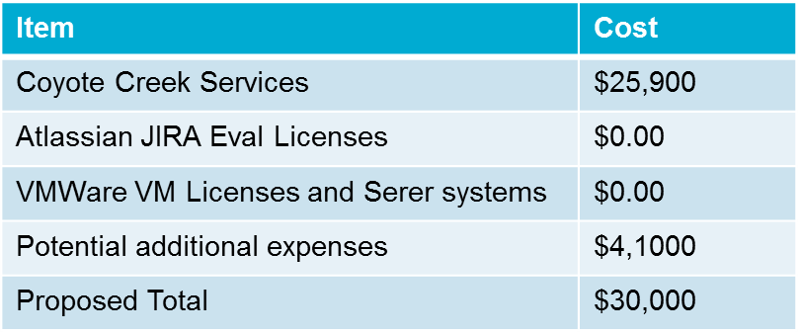
* **Next Steps & Timing:**

Approval from IT Steering commitee and engage vendor (Coyote Creek) to begin implementation per SoW.